
Airkrit India Pvt. Ltd.

New Delhi & Bengaluru
CIN - U85499DL2023PTC423549
www.airkrit.com support@airkrit.com
+91 8929252575

Certificate

DD-MM-YYYY
Dear [Your Name]


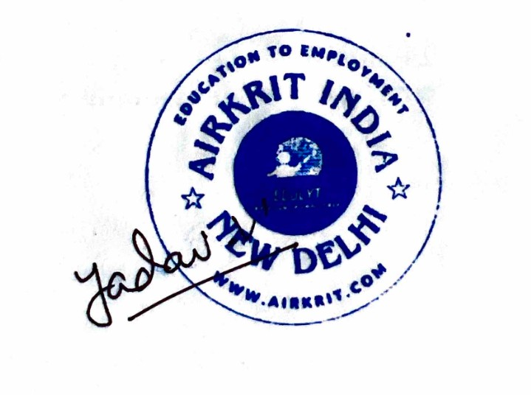
ID : AI-XXXX

TO WHOM SO EVER IT MAY CONCERN

This is to certify that [Full Name] has successfully completed the training on [Course Name] offered by Airkrit India. Through this program, [he/she] have acquired essential skills in [Key Topics or Technologies], demonstrating commitment to learning and professional growth.

During the training, [Full Name] engaged actively with our structured curriculum, including live sessions, mentorship interactions, and self-paced content. The training emphasized practical application of concepts, preparing [him/her] for future opportunities in the tech industry.

We acknowledge [his/her] dedication and performance, and wish [Full Name] continued success in applying these newly gained skills toward a rewarding career in technology.

[%qrImage]

Vishal Yadav – Manager HR

Airkrit India
Education to Employment

Note : Future verification can be done on verify@airkrit.com

